HandsMen Threads: Elevating the Art of Sophistication in Men's Fashion

ABSTRACT
This project presents a fully tailored Salesforce CRM solution developed for HandsMen Threads, a premium brand specializing in men’s fashion and bespoke tailoring. The system was designed to unify the company’s key operations sales, customer management, inventory tracking, and marketing into a single, intelligent platform. It incorporates five custom objects and a combination of automation tools such as Record-Triggered Flows, Scheduled Flows, Apex classes, and Email Alerts to streamline repetitive tasks and improve operational accuracy. Data quality and system security were reinforced through validation rules, permission sets, and role-based access control. By integrating all essential processes in one environment, HandsMen Threads gains better visibility of customer behavior, faster sales processing, and more reliable inventory monitoring. The solution provides a scalable foundation that supports long-term business growth and enhances the customer experience through timely notifications, personalized marketing, and improved service efficiency.

OBJECTIVE

- Develop a centralized Salesforce CRM that consolidates customer profiles, orders, inventory data, and marketing activities for seamless business operations.

- Create automated workflows using Flows, Email Alerts, and Apex to eliminate manual processes and increase productivity across teams.

- Foster stronger customer relationships through personalized communication, automated status updates, and targeted promotional messages.

- Ensure high data accuracy and security by implementing validation rules, permission controls, and role-based access for different business units.

- Build a scalable system architecture that can adapt to HandsMen Threads’ future expansion in both operations and customer reach.

- Enhance inventory management with automated low-stock alerts, scheduled batch updates, and real-time availability tracking.

TECHNICAL DESCRIPTION
The solution is built on Salesforce, a cloud-based CRM platform known for its flexibility, scalability, and extensive automation capabilities. Using Salesforce’s customizable features, the system incorporates five custom objects and multiple automated processes to support the unique workflow requirements of HandsMen Threads.
Record-Triggered Flows and Scheduled Flows handle essential automations such as order status updates, inventory replenishment checks, and timed marketing reminders. Apex was utilized for more complex operations including batch stock updates and advanced data processing. Email Alerts were set up to send customer notifications and internal reminders automatically.
To maintain data integrity and security, the system employs validation rules, permission sets, and a role hierarchy, ensuring that sensitive customer and business information is only accessible to authorized personnel. Salesforce’s cloud-based architecture also allows users to access the CRM from any device, enabling seamless collaboration between sales, marketing, and inventory teams.
Overall, the solution creates an efficient, accurate, and customer-centered CRM environment that optimizes business operations and supports the long-term growth of HandsMen Threads.

- Developer org setup:
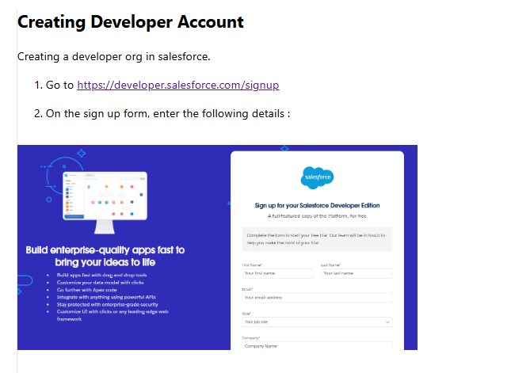

- Object creation:
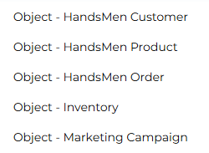

- Data management and lookup relationship
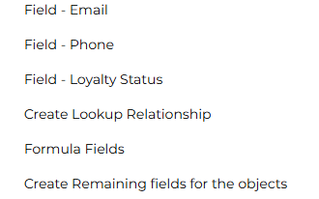

- Creating Validation rules
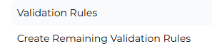

- Creating data configuration, Data Security- Profiles, Data Security- Roles, DataSecurity- Users and Data Security- Permission set
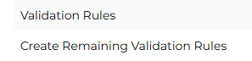
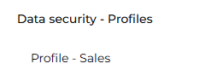
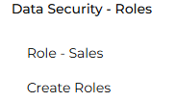
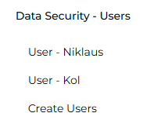
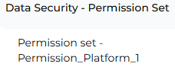

- Creating Email Template Email Template
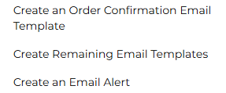

- Creating Flows
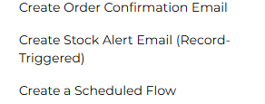

- Creating automation using Apex


Created Components:

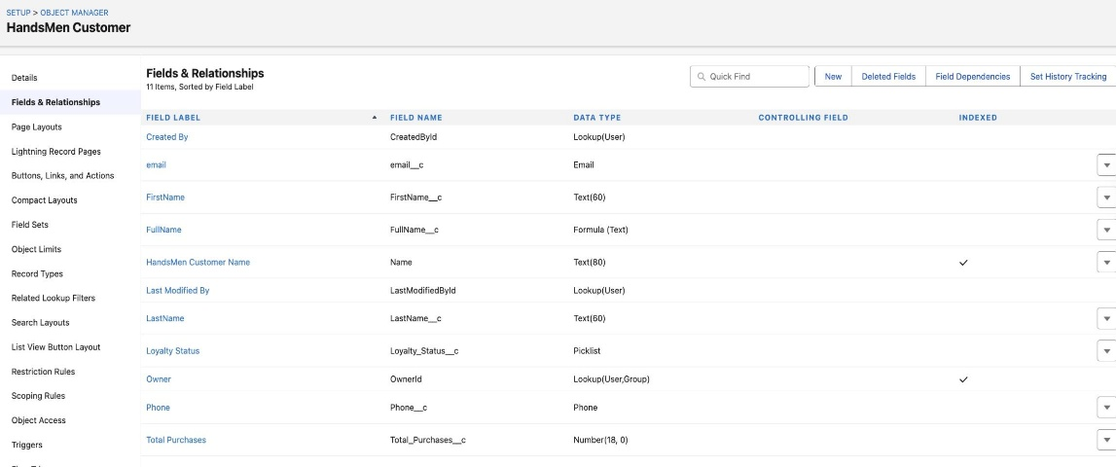
HandsMen Customer

HandsMen Orders
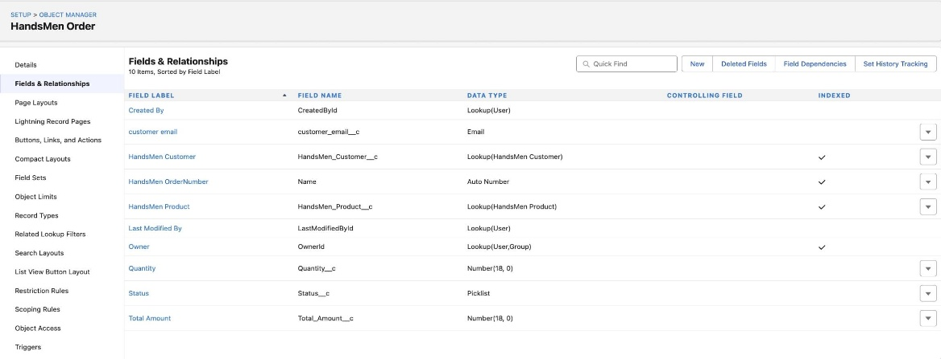

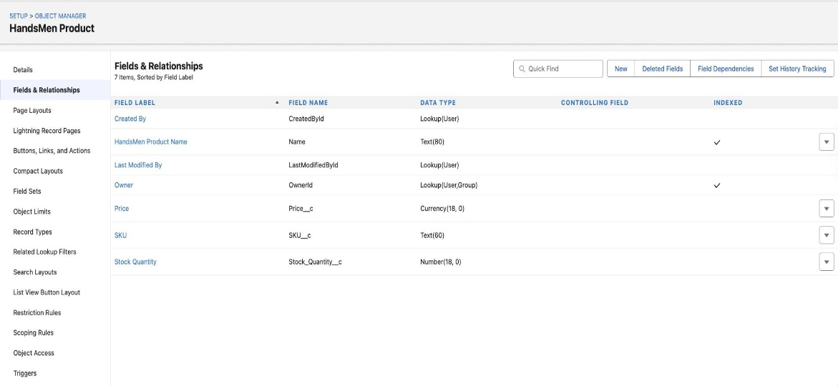
HandsMen Products
Inventorys
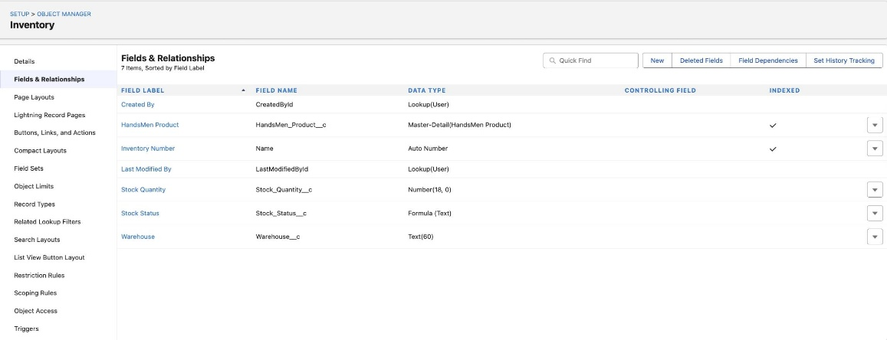

Marketing Campaigns
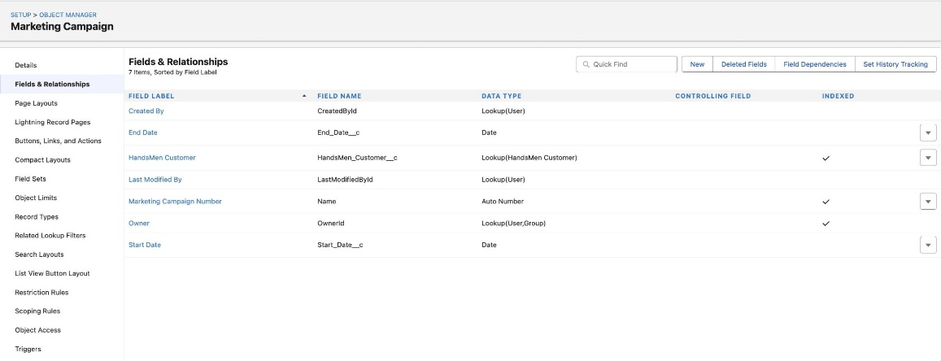

Order Confirmation Alert
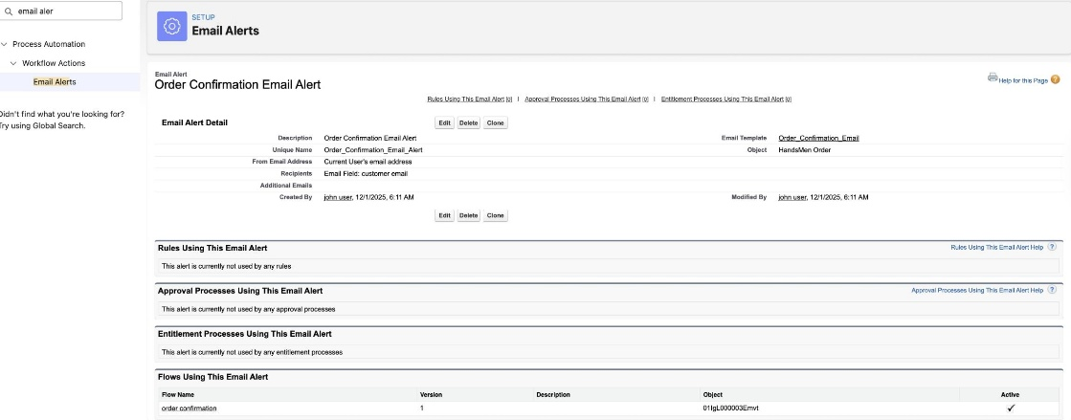

Low Stock Alert
